－　Original article　－

**Title (Times New Roman 10.5 pt Bold Centering)**

**－Subtitle in the second line if necessary (Time New Roman 10.5 pt Bold Centering)－**

Ichiro KANKYO * †, Hanako GAKKAI * * and Kenji KAGAKU ***

* Society of Environmental Science, 358-5 Yamabuki-cho Shinjuku-ku, Tokyo 162-0801, Japan

** Department of Engineering, University of Tokyo, 7-3-1 Hongo, Bunkyo-ku, Tokyo 113-9999, Japan (Second author’s affiliation and address)

*** (If all authors have same affiliation, * can be omitted.)

† Corresponding author: i-kankyo@xxx.or.jp

**Abstract**

This is a template for submitting the manuscripts to *Environmental Science*. The authors are recommended to overwrite on this template so that the manuscript is prepared according to the format of the journal. This would be helpful to the author(s) in checking an approximate length of article at the printed image and the editors and the reviewers in facilitating a speedy review process.

*Environmental Science* considers manuscripts for publication in the following types of papers, “Original article”, “Short communication”, “Technical report”, “Review” or “Special issue”. 32 lines are allocated for one page with 30 mm margin (left, right, top and bottom). Single column format is required. The type of paper should be shown in upper left side as “Original article”, “Short communication”, “Technical report”, “Review” or “Special issue”. The title page should include the title of the article, the names of all author(s), the affiliation(s) of author(s), the corresponding author’s Email address, an abstract, key words, and a running head of no more than 60 characters. The length of an abstract should be less than 200 words.

**Key Words：**Provide 5 keywords at the maximum, separated by comma.

**Running head：** no more than 60 characters

**1. Introduction**

The main body of manuscript starts from the next of the title page. Provide page number as 1 for the first main body page (this page). 32 lines are allocated for each page. Indicate line numbers. Blank line is inserted between chapters.

(blank line)

**2. Methods**

**2.1 Subsections**

Subsections should be numbered as 1.1 (then headings should be 1.1.1, 1.1.2, ...), 1.2…, .

**2.2 Fonts**

Times New Roman, 10.5pt is recommended.

(blank line)

**3. Results (or Results and Discussion)**

Please ensure that the figures and the tables are placed close to the relevant text in the manuscript. The figures and the tables should be prepared at a sufficient resolution for printing.

(blank line)

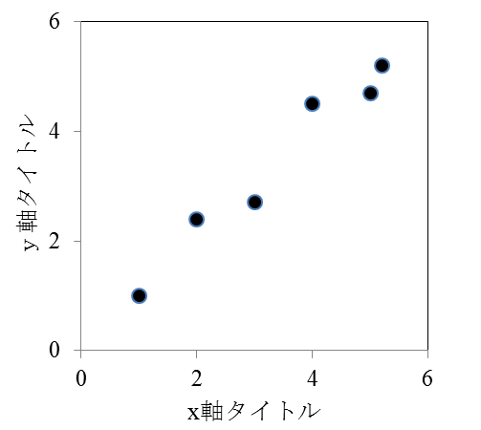

Horizontal axis label (minimum size: 1.5 mm)

Figure 1. Title is shown below the figure body

Table 1. Title is shown above the table body

|  |  |
| --- | --- |
|  | English manuscript |
| Margin (left, right, top and bottom) | 30 mm |
| Lines per page | 32 |
| Font | Times New Roman |
| Font size | 10.5pt |

**4.Discussion**

Reference is numbered continuously using upper style, such as ○○○○1)，○○○○2), 3)，○○○○4-7).

**References**

1. Seppala M., T. Paavola, A. Lehtomaki and J. Rintala (2009) Biogas production from boreal herbaceous grasses-Specific methane yield and methane yield per hectane. Bioresouce Technology, 100, 2952-2958.
2. Labar K. S. and J. E. LeDoux (2003) Emotional learning circuits in animals and humans. *In* R. J. Davidson, K. R. Scherer and H. H. Goldsmith (Eds) Handbook of Affective Sciences (Series in Affective Science), Oxford University Press, New York, 52-65.
3. FAO, FAOstat, http://faostat.fao.org/default.aspx,（accessed 2008-5-17）．

**日本語タイトル**

**－副題がある場合は2行目に（MS明朝/Time New Roman 10.5 pt Bold中揃え）－**

環境　一郎 * †・学会　花子 * *・科学　研二 ***

* （公社）環境科学会　〒162-0801 東京都新宿区山吹町358-5

** 2人目以降も所属先と住所を記載してください。

*** 全員の所属が同じ場合，*を用いた記載は不要です。

† Corresponding author: 連絡担当者のメールアドレスを記載してください。

**摘　要**

日本語摘要を800字以内（本テンプレートで25行以内）で書いてください。

**キーワード：**日本語5語以内でキーワードを書いてください。